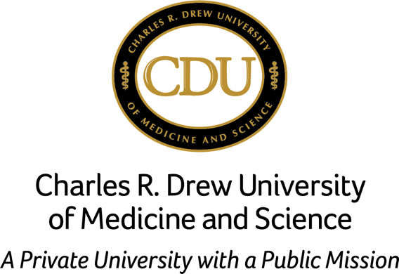

**September 24, 2017**

**6 p.m. to 9 p.m.**

Charles R. Drew University of Medicine and Science 1731 E 120th Street

Los Angeles, CA 90059

**This is a Call to Action at (323) 563-4939 or visit** [**www.cdrewu.edu**](http://www.cdrewu.edu/)

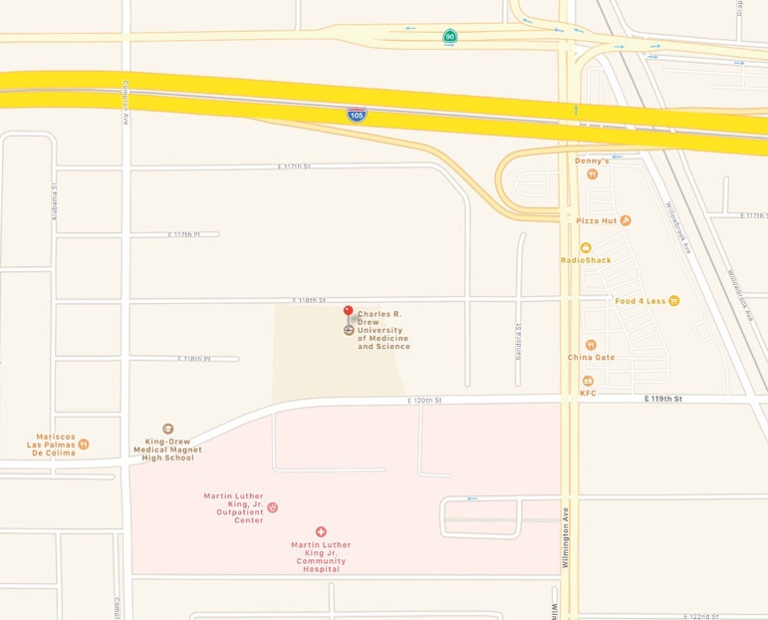

Iquam seque nus volorrum re dolor.

*Quidolupti ratquam explaut natatum ectur sunt et verum.*

**Dio tenest mollate mpelenis nonet labo nat eic testor sinciet omnihil.**

Omnis eicimax imincil moluptus inum nus, odita

corecest dolum con expligenis et que is et officip.   
Omnis eicimax imincil moluptus inum .